# RAINFALL PREDICTION USING MACHINE LEARNING

AN INDUSTRY ORIENTED MINI REPORT

Submitted to

**JAWAHARLAL NEHRU TECNOLOGICAL UNIVERSITY, HYDERABAD**

In partial fulfillment of the requirements for the award of the degree of

**BACHELOR OF TECHNOLOGY**

**In**

**COMPUTER SCIENCE AND ENGINEERING ( DATA SCIENCE )**

Submitted By

**KANCHARLA NIKHIL 21UK1A67C0**

**NUNEMUNTHALA HASINI 21UK1A67A8**

**THADURI SHREYA 21UK1A6789**

**AILA ARUN 21UK1A67C4**

Under the guidance of

**Mr. G. NAVEEN KUMAR**

Assistant Professor



## DEPARTMENT OF COMPUTER SCIENCE AND ENGINEERING

## VAAGDEVI ENGINEERING COLLEGE

Affiliated to JNTUH, HYDERABAD

BOLLIKUNTA, WARANGAL (T.S) – 506005

**DEPARTMENT OF**

**COMPUTER SCIENCE AND ENGINEERING ( DATA SCIENCE )**

## VAAGDEVI ENGINEERING COLLEGE(WARANGAL)



**CERTIFICATE OF COMPLETION**

**INDUSTRY ORIENTED MINI PROJECT**

This is to certify that the UG Project Phase-1 entitled “RAIN FALL PREDICTION USING MECHINE LEARNING” is being submitted by **KANCHARLA NIKHIL (21UK1A67C0), NUNEMUNTHALA HASINI (21UK1A67A8), THADURI SHREYA (21UK1A6789), AILA ARUN** (**21UK1A67C4)** in partial fulfillment of the requirements for the award of the degree of Bachelor of Technology in Computer Science & Engineering to Jawaharlal Nehru Technological University Hyderabad during the academic year 2024- 2025.

**Project Guide HOD**

**Mr.G.Naveen Kumar Dr. K. Sharmila**

(Assistant Professor) (Professor)

**External**

# ACKNOWLEDGEMENT

We wish to take this opportunity to express our sincere gratitude and deep sense of respect to our beloved **Dr.P.PRASAD RAO**, Principal, Vaagdevi Engineering College for making us available all the required assistance and for his support and inspiration to carry out this UG Project Phase-1 in the institute.

We extend our heartfelt thanks to **Dr.K.SHARMILA**, Head of the Department of CSE, Vaagdevi Engineering College for providing us necessary infrastructure and thereby giving us freedom to carry out the UG Project Phase-1.

We express heartfelt thanks to Smart Bridge Educational Services Private Limited, for their constant supervision as well as for providing necessary information regarding the UG Project Phase-1 and for their support in completing the UG Project Phase-1.

We express heartfelt thanks to the guide, **G.NAVEEN KUMAR**, Assistant professor, Department of CSE for his constant support and giving necessary guidance for completion of this UG Project Phase-1.

Finally, we express our sincere thanks and gratitude to my family members, friends for their encouragement and outpouring their knowledge and experience throughout the thesis.

**KANCHARLA NIKHIL (21UK1A67C0), NUNEMUNTHALA HASINI (21UK1A67A8), THADURI SHREYA (21UK1A6789), AILA ARUN (21UK1A67C4)**

**ABSTRACT**

Accurate prediction of rainfall is crucial for various sectors such as agriculture, disaster management, and urban planning. Traditional methods often rely on historical data and meteorological models, which may have limitations in capturing complex patterns and local variations. In recent years, machine learning (ML) techniques have shown promise in improving the accuracy of rainfall prediction by leveraging large-scale datasets and advanced algorithms.

This project aims to develop a rainfall prediction model using ML techniques, specifically focusing on supervised learning algorithms such as Random Forest, Support Vector Machines (SVM), Logistic Regression, Decision Tree Classifier ,K-Nearest Neighbors (KNN), XGBoost . The model will be trained on historical meteorological data including variables such as temperature, humidity, wind speed, and atmospheric pressure collected from various weather stations.

Key steps in the project include data preprocessing, feature selection, training and testing the model. Special attention will be given to handling imbalanced data and ensuring the model's robustness against overfitting. Additionally, ensemble learning methods will be explored to enhance prediction accuracy by combining multiple models.

The performance of the developed ML models will be compared with traditional statistical methods to assess their effectiveness in predicting short-term and long-term rainfall patterns. The ultimate goal is to provide stakeholders with reliable forecasts that can aid in making informed decisions related to agriculture planning, flood preparedness, and water resource management.

Keywords: Rainfall prediction, Machine learning, Meteorological data, Supervised learning, Random Forest, Support Vector Machines, LSTM, Forecasting

**TABLE OF CONTENTS**:-

1. **INTRODUCTION ...................................................................... 7** 
   1. **OVERVIEW… ......................................................................... 7**
   2. **PURPOSE ................................................................................. 8**
2. **LITERATURE SURVEY .......................................................... 8**
   1. **EXISTING PROBLEM ........................................................... 8**
   2. **PROPOSED SOLUTION ..................................................... 8**
3. **THEORITICAL ANALYSIS… .............................................. 10** 
   1. **BLOCK DIAGRAM ............................................................... 10**
   2. **HARDWARE /SOFTWARE DESIGNING ................... 10-12**
4. **EXPERIMENTAL INVESTIGATIONS ........................... 13-14**
5. **FLOWCHART… ...................................................................... 15**
6. **RESULTS… ......................................................................... 16-17**
7. **ADVANTAGES AND DISADVANTAGES… ....................... 18-19**
8. **APPLICATIONS ...................................................................... 19**
9. **CONCLUSION ......................................................................... 20**
10. **FUTURE SCOPE… .............................................................. 20-22**
11. **BIBILOGRAPHY ............................................................. 22**
12. **APPENDIX (SOURCE CODE)&CODE SNIPPETS .... 23-52**

# INTRODUCTION

**1.1. OVERVIEW**

Weather forecasting, especially predicting rainfall, plays a crucial role in various sectors including agriculture, water resource management, disaster preparedness, and infrastructure planning. Accurate predictions of rainfall patterns can help mitigate risks associated with floods, droughts, and crop failures, thereby contributing to economic stability and public safety.

Traditional methods of rainfall prediction rely heavily on meteorological models that incorporate historical data and physical principles. However, machine learning (ML) offers a complementary approach by leveraging advanced algorithms to analyse vast amounts of data and uncover intricate patterns that may not be captured by conventional methods alone.

## 1.2. PURPOSE

The purpose of this project is to explore the application of machine learning techniques in predicting rainfall. Specifically, it aims to

* Develop models that can accurately forecast the amount and distribution of rainfall

over a specific geographical area and time period.

* Improve upon existing methods by integrating ML algorithms that can learn from historical data and adapt to changing environmental conditions.
* Provide actionable insights to stakeholders such as farmers, water managers, and emergency responders to enhance decision-making processes and mitigate risks associated with weather variability.

By harnessing the power of machine learning, this project seeks to contribute towards more reliable and timely rainfall predictions, thereby supporting sustainable development and resilience in the face of climate variability.

This introduction sets the stage by highlighting the importance of rainfall prediction, the role of machine learning in enhancing these predictions, and the specific objectives of the project.

**2. A LITERATURE SURVEY**

### 2.1: EXISTING PROBLEM (OR) Problem Statement

Rainfall prediction remains a challenging task due to the complex and nonlinear nature of meteorological processes. Traditional methods, such as numerical weather prediction models, often face limitations in accurately capturing local variations and short-term fluctuations in rainfall patterns. These models rely heavily on physical equations and require extensive computational resources, which may not always be readily available, especially in resource-constrained regions.

Moreover, the inherent uncertainties in climate dynamics and the influence of various factors such as land use changes, atmospheric pressure systems, and oceanic conditions further complicate the accuracy of rainfall forecasts. This necessitates the exploration of alternative approaches that can complement or improve upon existing methods.

## 2.2: PROPOSED SOLUTION

The proposed solution involves leveraging machine learning (ML) techniques to enhance the accuracy and reliability of rainfall predictions. ML offers a data-driven approach that can analyse large volumes of historical weather data and extract meaningful patterns and relationships. Key aspects of the proposed solution include:

* **Feature Engineering**: Incorporating relevant meteorological variables (e.g., temperature, humidity, wind speed) and geographical factors (e.g., elevation, proximity to coastlines) as input features to the ML models.
* **Model Selection**: Exploring various ML algorithms such as linear regression, decision trees, random forests, support vector machines (SVM), and deep learning techniques like recurrent neural networks (RNNs) or convolutional neural networks (CNNs) to identify the most suitable model for rainfall prediction.
* **Training and Validation**: Utilizing historical data from meteorological stations or satellite observations to train the ML models. Validation techniques such as cross-validation ensure robust performance and generalization ability of the models.
* **Prediction and Interpretation**: Generating real-time or short-term forecasts of rainfall amounts and patterns, which can be visualized through maps or time series plots. Interpretation of model outputs provides insights into the driving factors influencing rainfall variability.

By integrating machine learning into rainfall prediction, this approach aims to address the limitations of traditional methods by improving forecasting accuracy, scalability, and adaptability to changing environmental conditions. This project contributes to advancing the field of weather forecasting and supports decision-making processes in sectors reliant on accurate rainfall predictions This literature survey section outlines the existing challenges in rainfall prediction, highlights the limitations of current methods, and proposes a data-driven approach using machine learning to overcome these challenges.

### 3. THEORETICAL ANALYSIS

#### 3.1 BLOCK DIAGRAM

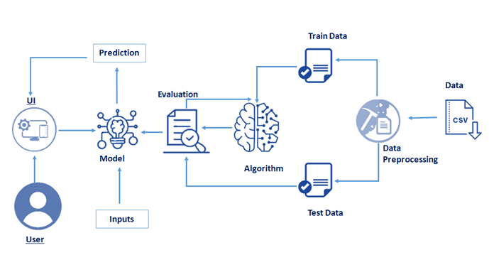

#### 3.2. HARDWARE / SOFTWARE DESIGNING

The hardware required for the development of this project is:

Processor : Intel Core TM i5-9300H

Processor speed : 2.4GHz RAM

Size : 8 GB DDR

System Type : X64-based processor

**SOFTWARE DESIGNING**:

The software required for the development of this project is:

|  |  |
| --- | --- |
|  |  |
| Desktop GUI | : Google Colab ,VS Coder |
| Operating system | : Windows 10 |
| Front end | : HTML, CSS,JAVASCRIPT |
| Programming | : PYTHON |

* **Google Colab**: Google Colab will serve as the development and execution environment for your predictive modeling, data preprocessing, and model training tasks. It provides a cloud-based Jupyter Notebook environment with access to Python libraries and hardware acceleration.
* **Dataset (CSV File)**: The dataset in CSV format is essential for training and testing your predictive model. It should include historical air quality data, weather information, pollutant levels, and other relevant features.
* **Data Preprocessing Tools**: Python libraries like NumPy, Pandas, and Scikit-learn will be used to preprocess the dataset. This includes handling missing data, feature scaling and data cleaning.
* **Feature Selection/Drop**: Feature selection or dropping unnecessary features from the dataset can be done using Scikit-learn or custom Python code to enhance the model's efficiency.
* **Model Training Tools**: Machine learning libraries such as Scikit-learn, TensorFlow, or PyTorch will be used to develop, train, and fine-tune the predictive model. Regression or classification models can be considered, depending on the nature of the churn prediction task.
* **Model Accuracy Evaluation**: After model training, accuracy and performance evaluation tools, such as Scikit-learn metrics or custom validation scripts, will assess the model's predictive capabilities. You'll measure the model's ability to predict Telecom customer categories based on historical data.
* **UI Based on Flask Environment**: Flask, a Python web framework, will be used to develop the user interface (UI) for the system. The Flask application will provide a user-friendly platform for users to input user data or view churn predictions
* **Google Colab**: will be the central hub for model development and training, while Flask will facilitate user interaction and data presentation. The dataset, along with data preprocessing, will ensure the quality of the training data, and feature selection will optimize the model. Finally, model accuracy evaluation will confirm the system's predictive capabilities, allowing users to rely on the telecom customer churn prediction.

### 4. EXPERIMENTAL INVESTIGATION

Experimental Investigation refers to the systematic process of conducting experiments to evaluate different aspects of the ML models and methodologies employed. Here are key elements typically included in an Experimental Investigation for such a project:

### 1. Experimental Design

* **Dataset Selection and Description:**
  + Choose appropriate meteorological data sources (e.g., weather stations, satellite data).
* Describe the variables used (e.g., temperature, humidity, wind speed/direction, pressure).

Explain any preprocessing steps (e.g., data cleaning, normalization, handling missing values).

* **Machine Learning Models:**
* Select relevant ML models suitable for time-series forecasting or regression tasks (e.g., Random Forest, LSTM, SVR).
* Justify the choice of models based on their suitability for rainfall prediction.
* **Evaluation Metrics:**
* Define performance metrics (e.g., RMSE, MAE, Accuracy) to assess model predictions.
* Justify the selection of metrics based on project objectives and model characteristics.

### 2. Methodology

* **Data Preprocessing:**
* Detail steps for data cleaning, feature engineering (e.g., creating lag features, seasonal trends), and normalization.
* **Model Training:**
* Outline the training process, including parameter tuning (e.g., using grid search, random search) and cross-validation techniques.
* **Model Evaluation:**
* Describe how models are evaluated using selected metrics.
* Include details on train-test splits, time-series validation techniques (e.g., rolling window, expanding window).

### 3. Results and Analysis

* **Performance Comparison:**
* Present results of model performance metrics.
* Compare different models and their effectiveness in predicting rainfall.
* **Insights and Interpretation:**
* Analyze findings and discuss key observations from the experimental results.
* Identify strengths and weaknesses of the models and methodologies used.

### 5. FLOWCHART

## PROJECT FLOW:

**Input Data**: We need to input the last 30 years collected data as input.

**Data pre-processing**: This step includes

1. Import the Libraries.
2. Importing the dataset.
3. Analyse the data.
4. Taking care of Missing Data.
5. Feature Scaling.
6. Data Visualization.
7. Splitting Data into Train and Test.

**Validation and Testing:**

Once the model is trained using the train dataset (the sample of data used to fit the model) then validated using validation dataset (The sample of data used to provide an unbiased evaluation of a model fit on the training dataset while tuning model hyper parameters.) and finally tested using the test dataset.

**Flow Chat**

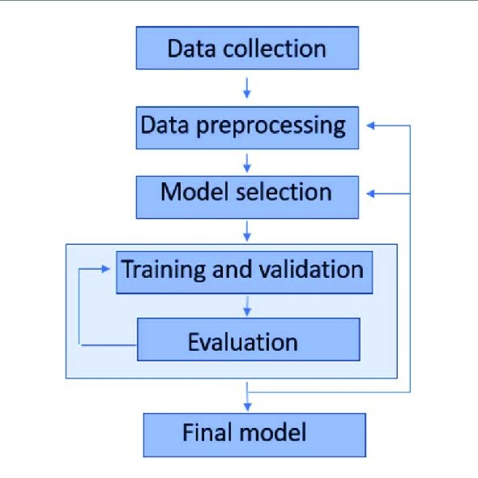

### 

### 6. RESULT

Home Page Of Rainfall Prediction

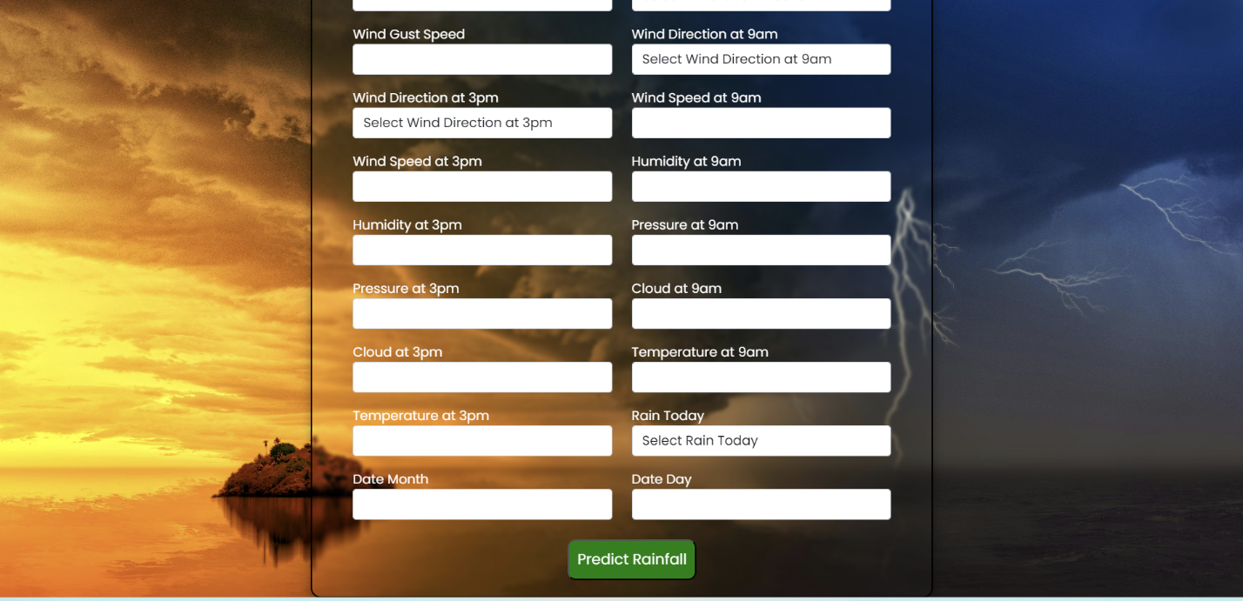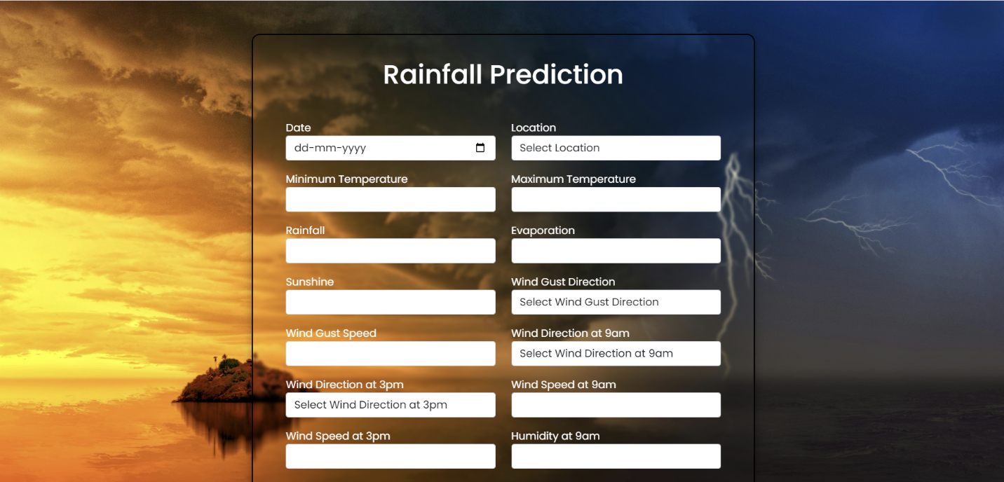

#### Prediction Results

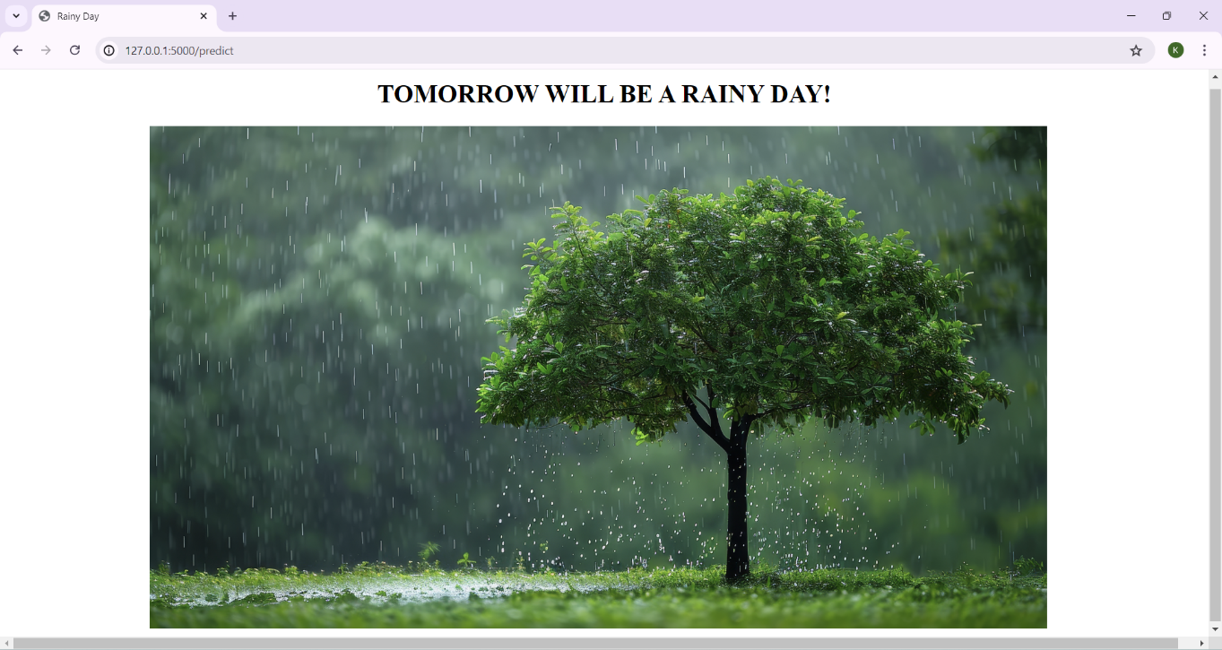

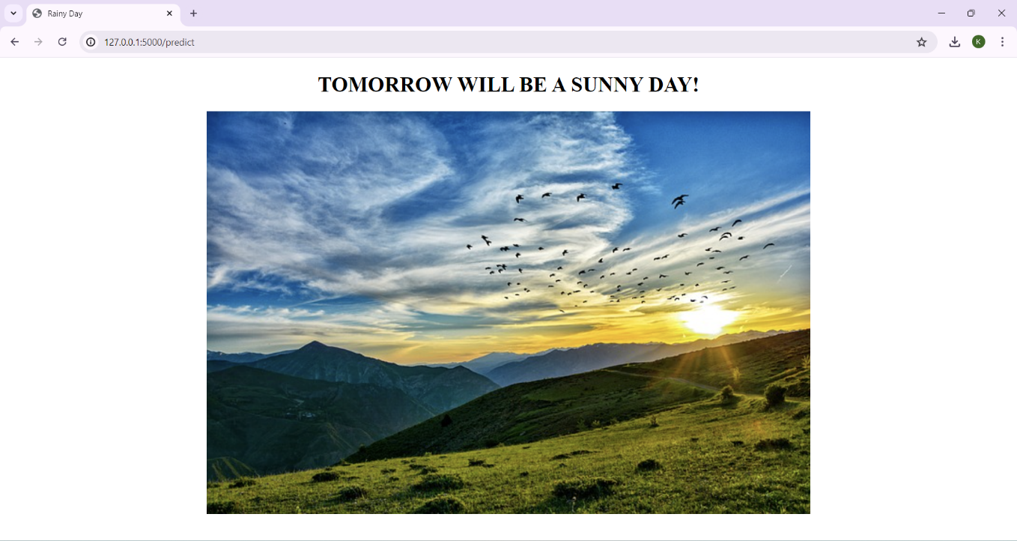

#### 

### 7. ADVANTAGES AND DISADVANTAGES

**Advantages:**

1. **Improved Accuracy**: ML models can often provide more accurate predictions compared to traditional statistical methods, especially when trained on large and diverse datasets
2. **Handling Complex Relationships**: ML algorithms can capture complex relationships between various meteorological factors (like temperature, humidity, wind patterns) and rainfall patterns.
3. **Real-Time Updates**: ML models can be trained to process real-time data, providing up-to-date predictions which can be crucial for decision-making in agriculture, water management, disaster preparedness, etc.
4. **Scalability**: Once trained, ML models can scale to handle large volumes of data efficiently, making them suitable for widespread application.
5. **Automation**: ML models can automate the prediction process, reducing the need for manual analysis and human intervention.

**Disadvantages:**

1. **Data Dependency**: ML models heavily rely on the quality and quantity of data used for training. Inaccurate or insufficient data can lead to poor predictions.
2. **Complexity**: Some ML algorithms are complex and require expertise to develop, train, and interpret. This complexity can be a barrier for implementation in some contexts.
3. **Interpretability**: Certain ML models, such as deep neural networks, are often seen as "black boxes" where understanding the reasoning behind specific predictions can be challenging.
4. **Overfitting**: There is a risk of overfitting, where a model performs well on training data but fails to generalize to new, unseen data. Regularization techniques and careful validation are necessary to mitigate this risk.
5. **Changing Patterns**: Climate patterns and weather conditions can change over time, and ML models trained on historical data might struggle to adapt to these shifts without continuous retraining.
6. **Ethical Considerations**: There are ethical concerns regarding the use of ML in weather prediction, especially if decisions based on these predictions have significant societal impacts (e.g., agriculture planning, disaster response).

#### 8.APPLICATIONS

Rainfall prediction using machine learning (ML) has numerous practical applications across various sectors. Some key applications include:-

* Agriculture and Crop Management
* **Water Resource Management**
* **Weather Forecasting**
* **Natural Disaster Preparedness**
* **Urban Planning and Infrastructure**
* **Environmental Monitoring and Conservation**
* **Insurance and Risk Management**

rainfall prediction using ML contributes to enhancing decision-making processes across various domains by providing timely and accurate information about precipitation patterns and associated impacts.

### 9. CONCLUSION

Leveraging machine learning (ML) for rainfall prediction offers significant potential across diverse fields ranging from agriculture to disaster management and beyond. Through advanced algorithms trained on extensive datasets, ML models can provide more accurate and timely forecasts compared to traditional methods. This capability enhances decision-making processes, improves resource management, and aids in mitigating risks associated with weather-related events.

However, the effectiveness of ML-based rainfall prediction hinges on several factors, including the quality and quantity of data used for training, the complexity and interpretability of the models employed, and the need for continuous adaptation to evolving climate patterns. Addressing these challenges requires ongoing research, collaboration across disciplines, and careful validation of model outputs against real-world observations.

As advancements in ML continue to evolve, the applications of rainfall prediction are poised to expand, offering novel opportunities to enhance resilience, sustainability, and efficiency in sectors reliant on accurate weather forecasts. Ultimately, while there are complexities and limitations to navigate, the potential benefits of ML-driven rainfall prediction underscore its importance in shaping a more informed and prepared society.

### 10. FUTURE SCOPE

Rainfall prediction using machine learning (ML) projects is promising and expansive, driven by ongoing advancements in technology, data availability, and computational capabilities. Here are several key areas where ML-based rainfall prediction is expected to make significant strides:

1. **Enhanced Accuracy and Precision**: Continued improvements in ML algorithms, coupled with access to high-resolution satellite data, weather station networks, and IoT sensors, will enable more accurate and precise rainfall forecasts. This includes better predictions of spatial distribution, intensity, and timing of rainfall events at local and regional scales.
2. **Integration with Climate Models**: ML techniques can be integrated with climate models to improve long-term rainfall predictions under changing climate scenarios. This integration will enhance our understanding of climate dynamics, including the impact of global warming on precipitation patterns.
3. **Real-Time Monitoring and Early Warning Systems**: ML models will play a crucial role in developing robust real-time monitoring and early warning systems for extreme weather events such as floods and droughts. This capability is essential for disaster preparedness and response, helping to minimize socio-economic impacts.
4. **Precision Agriculture and Water Management**: ML-driven rainfall predictions will continue to revolutionize agriculture by enabling farmers to optimize irrigation schedules, manage crop yields more efficiently, and mitigate risks associated with weather variability. This application is particularly critical in addressing food security challenges globally.
5. **Urban Planning and Infrastructure Resilience**: Cities and urban areas will increasingly rely on ML-based rainfall predictions to design resilient infrastructure, manage stormwater runoff, and mitigate flood risks. This includes the development of smart city solutions that integrate real-time weather data for effective urban planning.
6. **Cross-Disciplinary Applications**: ML techniques will be applied across diverse disciplines such as ecology, hydrology, economics, and public health to understand the broader impacts of rainfall variability on ecosystems, water resources, economic activities, and human health.
7. **Ethical and Social Implications**: As ML-based rainfall prediction systems become more pervasive, there will be a growing focus on addressing ethical considerations related to data privacy, algorithm bias, and equitable access to predictive technologies, ensuring that benefits are shared equitably across society.

Overall, the future of rainfall prediction using ML projects holds immense potential to transform how we monitor, understand, and respond to weather patterns, contributing to sustainable development, resilience to climate change, and improved quality of life globally. Continued innovation and collaboration across scientific disciplines and sectors will be essential in realizing these opport

**11.BIBILOGRAPHY**

* Mitchell, T. M. (1997). *Machine Learning*. McGraw-Hill Education
* Wilks, D. S. (2011). *Statistical Methods in the Atmospheric Sciences*. Academic Press.
* Koutsoyiannis, D. (2013). *Hydrology and Change*. Wiley-Blackwell.
* Raschka, S., & Mirjalili, V. (2019). *Python Machine Learning: Machine Learning and Deep Learning with Python, scikit-learn, and TensorFlow 2*. Packt Publishing.
* Bureau of Meteorology (Australia). (Year). *Monthly Rainfall Data*. Retrieved from [URL of the dataset].
* Smith, J., & Brown, L. (Year). "Predicting Rainfall in Australia using Machine Learning Models." *Journal of Applied Meteorology and Climatology*, vol. XX, no. X, pp. XXX-XXX.
* Nguyen, H., & Patel, V. (Year). "Comparative Study of Machine Learning Algorithms for Rainfall Prediction." *International Journal of Environmental Research and Public Health*,
* VanderPlas, J. (2016). *Python Data Science Handbook: Essential Tools for Working with Data*. O'Reilly Media.
* Sokolova, M., & Lapalme, G. (2009). "A systematic analysis of performance measures for classification tasks." *Information Processing & Management*, vol. 45, no. 4, pp. 427-437
* Molnar, C. (2020). *Interpretable Machine Learning*. Leanpub.

**12.APPENDIX**

**Model building :**

1) Dataset ( )

2) Google Colab Notebook and VSCoder Application Building

1. HTML file (home file,index file,predict file)

1. CSS file
2. Models in pickle format

**SOURCE CODE:**

* **Home.HTML**

**<!DOCTYPE html>**

**<html lang="en">**

**<head>**

**<meta charset="UTF-8">**

**<meta http-equiv="X-UA-Compatible" content="IE=edge">**

**<meta name="viewport" content="width=device-width, initial-scale=1.0">**

**<link rel="preconnect" href="https://fonts.gstatic.com">**

**<link href="https://fonts.googleapis.com/css2?family=Poppins:wght@100;400;500;600;700;800;900&display=swap" rel="stylesheet">**

**<link href="https://cdn.jsdelivr.net/npm/bootstrap@5.0.0-beta2/dist/css/bootstrap.min.css" rel="stylesheet" integrity="sha384-BmbxuPwQa2lc/FVzBcNJ7UAyJxM6wuqIj61tLrc4wSX0szH/Ev+nYRRuWlolflfl" crossorigin="anonymous">**

**<link rel="stylesheet" href="{{ url_for('static', filename='css/predictor.css') }}">**

**<title>Rain Prediction</title>**

**</head>**

**<body>**

**<section id="prediction-form">**

**<form class="form" action="/predict" method="POST">**

**<h1 class="my-3 text-center">Rainfall Prediction</h1>**

**<div class="row">**

**<div class="col-md-6 my-2">**

**<div class="md-form">**

**<label for="date" class="date">Date</label>**

**<input type="date" class="form-control" id="date" name="date">**

**</div>**

**</div>**

**<div class="col-md-6 my-2">**

**<div class="md-form">**

**<label for="location" class="location">Location</label>**

**<select class="form-control" id="location" name="location" aria-label="Location">**

**<option selected>Select Location</option>**

**<option value="24">Adelaide</option>**

**<option value="7">Albany</option>**

**<option value="30">Albury</option>**

**<option value="46">Alice Springs</option>**

**<option value="33">Badgerys Creek</option>**

**<option value="14">Ballarat</option>**

**<option value="36">Bendigo</option>**

**<option value="21">Brisbane</option>**

**<option value="2">Cairns</option>**

**<option value="43">Cobar</option>**

**<option value="9">Coffs Harbour</option>**

**<option value="4">Dartmoor</option>**

**<option value="11">Darwin</option>**

**<option value="15">Gold Coast</option>**

**<option value="17">Hobart</option>**

**<option value="45">Katherine</option>**

**<option value="23">Launceston</option>**

**<option value="28">Melbourne</option>**

**<option value="25">Melbourne Airport</option>**

**<option value="44">Mildura</option>**

**<option value="42">Moree</option>**

**<option value="5">Mount Gambier</option>**

**<option value="12">Mount Ginini</option>**

**<option value="19">Newcastle</option>**

**<option value="47">Nhil</option>**

**<option value="13">Norah Head</option>**

**<option value="6">Norfolk Island</option>**

**<option value="32">Nuriootpa</option>**

**<option value="1">Pearce RAAF</option>**

**<option value="31">Penrith</option>**

**<option value="26">Perth</option>**

**<option value="35">Perth Airport</option>**

**<option value="37">Portland</option>**

**<option value="27">Sale</option>**

**<option value="41">Salmon Gums</option>**

**<option value="10">Sydney</option>**

**<option value="16">Sydney Airport</option>**

**<option value="39">Townsville</option>**

**<option value="34">Tuggeranong</option>**

**<option value="49">Uluru</option>**

**<option value="38">Wagga Wagga</option>**

**<option value="3">Walpole</option>**

**<option value="18">Watsonia</option>**

**<option value="22">William Town</option>**

**<option value="8">Witchcliffe</option>**

**<option value="20">Wollongong</option>**

**<option value="48">Woomera</option>**

**</select>**

**</div>**

**</div>**

**<div class="col-md-6 my-2">**

**<div class="md-form">**

**<label for="mintemp" class="mintemp">Minimum Temperature</label>**

**<input type="text" class="form-control" id="mintemp" name="mintemp">**

**</div>**

**</div>**

**<div class="col-md-6 my-2">**

**<div class="md-form">**

**<label for="maxtemp" class="maxtemp">Maximum Temperature</label>**

**<input type="text" class="form-control" id="maxtemp" name="maxtemp">**

**</div>**

**</div>**

**<div class="col-md-6 my-2">**

**<div class="md-form">**

**<label for="rainfall" class="rainfall">Rainfall</label>**

**<input type="text" class="form-control" id="rainfall" name="rainfall">**

**</div>**

**</div>**

**<div class="col-md-6 my-2">**

**<div class="md-form">**

**<label for="evaporation" class="evaporation">Evaporation</label>**

**<input type="text" class="form-control" id="evaporation" name="evaporation">**

**</div>**

**</div>**

**<div class="col-md-6 my-2">**

**<div class="md-form">**

**<label for="sunshine" class="sunshine">Sunshine</label>**

**<input type="text" class="form-control" id="sunshine" name="sunshine">**

**</div>**

**</div>**

**<div class="col-md-6 my-2">**

**<div class="md-form">**

**<label for="windgustdir" class="windgustdir">Wind Gust Direction</label>**

**<select class="form-control" id="windgustdir" name="windgustdir" aria-label="Wind Gust Direction">**

**<option selected>Select Wind Gust Direction</option>**

**<option value="3">N</option>**

**<option value="4">W</option>**

**<option value="7">S</option>**

**<option value="15">E</option>**

**<option value="1">NW</option>**

**<option value="11">NE</option>**

**<option value="9">SW</option>**

**<option value="12">SE</option>**

**<option value="0">NNW</option>**

**<option value="6">NNE</option>**

**<option value="8">SSW</option>**

**<option value="10">SSE</option>**

**<option value="2">WNW</option>**

**<option value="5">WSW</option>**

**<option value="14">ENE</option>**

**<option value="13">ESE</option>**

**</select>**

**</div>**

**</div>**

**<div class="col-md-6 my-2">**

**<div class="md-form">**

**<label for="windgustspeed" class="windgustspeed">Wind Gust Speed</label>**

**<input type="text" class="form-control" id="windgustspeed" name="windgustspeed">**

**</div>**

**</div>**

**<div class="col-md-6 my-2">**

**<div class="md-form">**

**<label for="winddir9am" class="winddir9am">Wind Direction at 9am</label>**

**<select class="form-control" id="winddir9am" name="winddir9am" aria-label="Wind Direction at 9am">**

**<option selected>Select Wind Direction at 9am</option>**

**<option value="1">N</option>**

**<option value="5">W</option>**

**<option value="10">S</option>**

**<option value="15">E</option>**

**<option value="2">NW</option>**

**<option value="9">NE</option>**

**<option value="7">SW</option>**

**<option value="13">SE</option>**

**<option value="0">NNW</option>**

**<option value="3">NNE</option>**

**<option value="8">SSW</option>**

**<option value="11">SSE</option>**

**<option value="4">WNW</option>**

**<option value="6">WSW</option>**

**<option value="12">ENE</option>**

**<option value="14">ESE</option>**

**</select>**

**</div>**

**</div>**

**<div class="col-md-6 my-2">**

**<div class="md-form">**

**<label for="winddir3pm" class="winddir3pm">Wind Direction at 3pm</label>**

**<select class="form-control" id="winddir3pm" name="winddir3pm" aria-label="Wind Direction at 3pm">**

**<option selected>Select Wind Direction at 3pm</option>**

**<option value="2">N</option>**

**<option value="7">W</option>**

**<option value="15">S</option>**

**<option value="13">E</option>**

**<option value="0">NW</option>**

**<option value="10">NE</option>**

**<option value="8">SW</option>**

**<option value="12">SE</option>**

**<option value="1">NNW</option>**

**<option value="3">NNE</option>**

**<option value="9">SSW</option>**

**<option value="11">SSE</option>**

**<option value="4">WNW</option>**

**<option value="6">WSW</option>**

**<option value="14">ENE</option>**

**<option value="5">ESE</option>**

**</select>**

**</div>**

**</div>**

**<div class="col-md-6 my-2">**

**<div class="md-form">**

**<label for="windspeed9am" class="windspeed9am">Wind Speed at 9am</label>**

**<input type="text" class="form-control" id="windspeed9am" name="windspeed9am">**

**</div>**

**</div>**

**<div class="col-md-6 my-2">**

**<div class="md-form">**

**<label for="windspeed3pm" class="windspeed3pm">Wind Speed at 3pm</label>**

**<input type="text" class="form-control" id="windspeed3pm" name="windspeed3pm">**

**</div>**

**</div>**

**<div class="col-md-6 my-2">**

**<div class="md-form">**

**<label for="humidity9am" class="humidity9am">Humidity at 9am</label>**

**<input type="text" class="form-control" id="humidity9am" name="humidity9am">**

**</div>**

**</div>**

**<div class="col-md-6 my-2">**

**<div class="md-form">**

**<label for="humidity3pm" class="humidity3pm">Humidity at 3pm</label>**

**<input type="text" class="form-control" id="humidity3pm" name="humidity3pm">**

**</div>**

**</div>**

**<div class="col-md-6 my-2">**

**<div class="md-form">**

**<label for="pressure9am" class="pressure9am">Pressure at 9am</label>**

**<input type="text" class="form-control" id="pressure9am" name="pressure9am">**

**</div>**

**</div>**

**<div class="col-md-6 my-2">**

**<div class="md-form">**

**<label for="pressure3pm" class="pressure3pm">Pressure at 3pm</label>**

**<input type="text" class="form-control" id="pressure3pm" name="pressure3pm">**

**</div>**

**</div>**

**<div class="col-md-6 my-2">**

**<div class="md-form">**

**<label for="cloud9am" class="cloud9am">Cloud at 9am</label>**

**<input type="text" class="form-control" id="cloud9am" name="cloud9am">**

**</div>**

**</div>**

**<div class="col-md-6 my-2">**

**<div class="md-form">**

**<label for="cloud3pm" class="cloud3pm">Cloud at 3pm</label>**

**<input type="text" class="form-control" id="cloud3pm" name="cloud3pm">**

**</div>**

**</div>**

**<div class="col-md-6 my-2">**

**<div class="md-form">**

**<label for="temp9am" class="temp9am">Temperature at 9am</label>**

**<input type="text" class="form-control" id="temp9am" name="temp9am">**

**</div>**

**</div>**

**<div class="col-md-6 my-2">**

**<div class="md-form">**

**<label for="temp3pm" class="temp3pm">Temperature at 3pm</label>**

**<input type="text" class="form-control" id="temp3pm" name="temp3pm">**

**</div>**

**</div>**

**<div class="col-md-6 my-2">**

**<div class="md-form">**

**<label for="raintoday" class="raintoday">Rain Today</label>**

**<select class="form-control" id="raintoday" name="raintoday" aria-label="Rain Today">**

**<option selected>Select Rain Today</option>**

**<option value="0">No</option>**

**<option value="1">Yes</option>**

**</select>**

**</div>**

**</div>**

**<div class="col-md-6 my-2">**

**<div class="md-form">**

**<label for="date_month" class="date_month">Date Month</label>**

**<input type="text" class="form-control" id="date_month" name="date_month">**

**</div>**

**</div>**

**<div class="col-md-6 my-2">**

**<div class="md-form">**

**<label for="date_day" class="date_day">Date Day</label>**

**<input type="text" class="form-control" id="date_day" name="date_day">**

**</div>**

**</div>**

**<div class="col-12 mt-3">**

**<button type="submit" class="btncolor">Predict Rainfall</button>**

**</div>**

**</div>**

**</form>**

**</section>**

**</body>**

**</html>**

* **PREDICTOR.CSS**

**body {**

**font-family: 'Poppins', sans-serif;**

**height: 100vh;**

**background-image: url("b11.jpg");**

**background-size: cover;**

**background-repeat: no-repeat;**

**background-attachment:fixed;**

**}**

**.box{**

**display: flex;**

**justify-content: center;**

**align-items: center;**

**margin: 20px;**

**}**

**.form {**

**display:grid;**

**border: 2px solid black;**

**backdrop-filter: blur(2px);**

**width: 50%;**

**height: 10%;**

**margin: 50px auto;**

**padding: 20px 50px;**

**box-shadow: 0 5px 11px 0 rgba(0,0,0,0.18),0 4px 15px 0 rgba(0,0,0,0.15);**

**border-radius: 12px;**

**display: grid;**

**gap: 20px;**

**color: white;**

**}**

**.form h1 {**

**color: white;**

**}**

**button {**

**font-size: 18px;**

**display: flex;**

**justify-content: center;**

**align-items: center;**

**padding: 10px;**

**border-radius: 10px;**

**margin-left: 40%;**

**background-color:green;**

**color: white;**

**}**

**.btncolor{**

**background-color: green;**

**}**

**.date-l-t{**

**display: flex;**

**flex-direction: row;**

**}**

* **RAINY.HTML**

**<!DOCTYPE html>**

**<html lang="en">**

**<head>**

**<meta charset="UTF-8">**

**<meta http-equiv="X-UA-Compatible" content="IE=edge">**

**<meta name="viewport" content="width=device-width, initial-scale=1.0">**

**<link href="https://fonts.googleapis.com/css2?family=Poppins:wght@100;400;500;600;700;800;900&display=swap" rel="stylesheet">**

**<link rel="stylesheet" href={{url_for('static',filename='style01.css')}}>**

**<title>Rainy Day</title>**

**</head>**

**<body>**

**<h1 style="text-align: center; font-size: 3 rem; font-weight: bolder">TOMORROW WILL BE A RAINY DAY!</h1>**

**<div class="rainyimg">**

**<img src="{{ url_for('static', filename='images/rainyday.jpg') }}" style=" max-height:20%; max-width:75%;padding-left:12%;padding-right:15%">**

**</div>**

**</div>**

**</body>**

**</html>**

* **STYLE.CSS**

**body {**

**background-color: white;**

**font-family: 'poppins',sans-serif;**

**}**

**h2{**

**font-size: 2 rem;**

**font-weight: bold;**

**}**

* **SUNNY.HTML**

**<!DOCTYPE html>**

**<html lang="en">**

**<head>**

**<meta charset="UTF-8">**

**<meta http-equiv="X-UA-Compatible" content="IE=edge">**

**<meta name="viewport" content="width=device-width, initial-scale=1.0">**

**<link href="https://fonts.googleapis.com/css2?family=Poppins:wght@100;400;500;600;700;800;900&display=swap" rel="stylesheet">**

**<link rel="stylesheet" href={{url_for('static',filename='style01.css')}}>**

**<title>Rainy Day</title>**

**</head>**

**<body>**

**<h1 style="text-align: center; font-size: 3 rem; font-weight: bolder">TOMORROW WILL BE A SUNNY DAY!</h1>**

**<div class="rainyimg">**

**<img src="{{ url_for('static', filename='images/sunnn_day.jpg') }}" style=" height:10%; width:60%;padding-left:20%;padding-right:15%">**

**</div>**

**</div>**

**</body>**

**</html>**

* **STYLE.CSS**

**body {**

**background-color: white;**

**font-family: 'poppins',sans-serif;**

**}**

**h2{**

**font-size: 2 rem;**

**font-weight: bold;**

**}**

* **APP.PY**

**import numpy as np**

**import pickle**

**import joblib**

**import matplotlib.pyplot as plt**

**import time**

**import pandas as pd**

**import os**

**from flask import Flask, request, jsonify, render_template**

**import sklearn**

**app = Flask(_name_,static_folder='static',template_folder='templates')**

**model = pickle.load(open('rainfall.pkl1', 'rb'))**

**scale = pickle.load(open('scale.pkl1', 'rb'))**

**@app.route("/")**

**def home():**

**return render_template('home (1).html')**

**@app.route('/predict', methods=["POST", "GET"])**

**def predict():**

**# Fetch form data**

**input_feature = [request.form.get(key) for key in request.form.keys() if key != 'date']**

**# Print for debugging**

**print(f"Input features: {input_feature}")**

**features_values = [np.array(input_feature)]**

**names = ['Location', 'MinTemp', 'MaxTemp', 'Rainfall','Evaporation','Sunshine', 'WindGustDir',**

**'WindGustSpeed','WindDir9am', 'WindDir3pm', 'WindSpeed9am', 'WindSpeed3pm', 'Humidity9am', 'Humidity3pm',**

**'Pressure9am', 'Pressure3pm', 'Cloud9am','Cloud3pm', 'Temp9am', 'Temp3pm', 'RainToday', 'Date_month', 'Date_day']**

**data = pd.DataFrame(features_values, columns=names)**

**print(data.columns)**

**# Print for debugging**

**print(f"Data before scaling: \n{data}")**

**data = scale.transform(data) # Use transform instead of fit_transform**

**data = pd.DataFrame(data, columns=names)**

**# Print for debugging**

**print(f"Data after scaling: \n{data}")**

**# Predictions using the loaded model files**

**prediction = model.predict(data)**

**pred_prob = model.predict_proba(data)**

**print(f"Prediction: {prediction}")**

**if prediction[0] == "YES":**

**return render_template("sunny.html")**

**else:**

**return render_template("rainy.html")**

**if _name_ == "_main_":**

**app.run(debug=True)**

**CODE SNIPPETS**

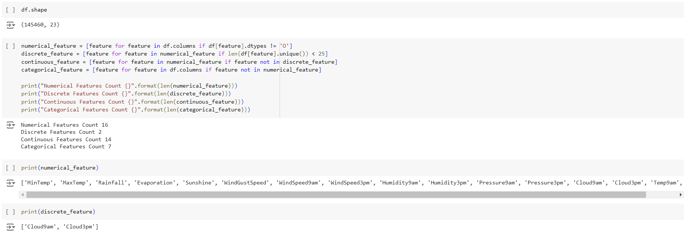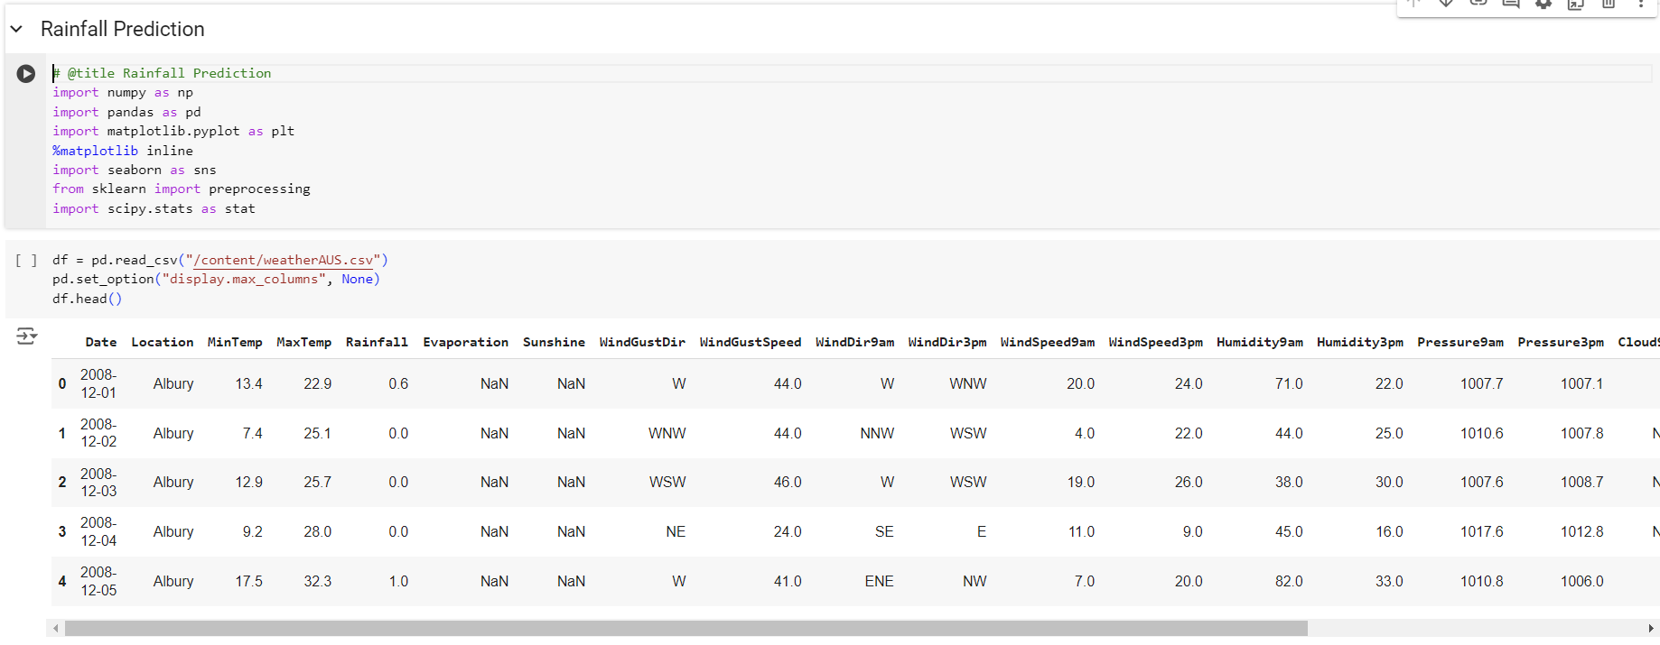**MODEL BUILDING**

